# 4. Implement program for Linear Regression Model of a time series data.

|  |  |
| --- | --- |
| **EX.N0 : 4** | **Implement program for Linear Regression Model of a time series data.** |
| **DATE : 20/02/2025** |

**AIM:**

Implement program for Linear Regression Model of a time series data.

# PROGRAM:

import pandas as pd

import numpy as np

import matplotlib.pyplot as plt

from sklearn.model_selection import train_test_split

from sklearn.linear_model import LinearRegression

from sklearn.metrics import mean_squared_error

# Load the dataset

file_path = "C:/Users/Lenovo/Downloads/climate_change_data.csv"

df = pd.read_csv(file_path)

# Convert 'Date' to datetime and sort

df['Date'] = pd.to_datetime(df['Date'])

df = df.sort_values(by='Date')

# Convert 'Date' to numerical format (ordinal values)

df['Date_Ordinal'] = df['Date'].map(lambda x: x.toordinal())

# Selecting features and target variable

X = df[['Date_Ordinal', 'CO2 Emissions', 'Sea Level Rise', 'Precipitation', 'Humidity', 'Wind Speed']]

y = df['Temperature']

# Split the data into training and testing sets

X_train, X_test, y_train, y_test = train_test_split(X, y, test_size=0.2, random_state=42, shuffle=False)

# Train the Linear Regression model

model = LinearRegression()

model.fit(X_train, y_train)

# Predictions and evaluation

y_pred = model.predict(X_test)

mse = mean_squared_error(y_test, y_pred)

rmse = np.sqrt(mse)

# Visualization

plt.figure(figsize=(12, 6))

plt.plot(df['Date'].iloc[len(y_train):], y_test, label="Actual Temperature", color="blue", alpha=0.6)

plt.plot(df['Date'].iloc[len(y_train):], y_pred, label="Predicted Temperature", color="red", linestyle="dashed")

plt.xlabel("Date")

plt.ylabel("Temperature (°C)")

plt.title("Actual vs Predicted Temperature Over Time")

plt.legend()

plt.show()

# Output model performance

print("Model Coefficients:", model.coef_)

print("Intercept:", model.intercept_)

print("Root Mean Squared Error (RMSE):", rmse)

**OUTPUT:**

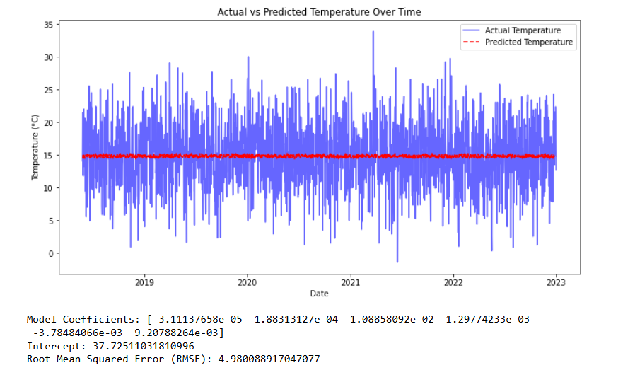

# RESULT:

Thus, the program for Implement programs for Implement programs for linear regression model of a time series data is executed successfully.